Final Project Week 3 Manual Test Plan

This is a manual test plan that provides guide to install environment for, to run, and to test the React project in week 3 of final project.

**Prerequisites**

* React
* PyCharm

**Environment Setup**

The flask program file is ‘novel_api_2.py’.

The main program file is ‘app.js’ and ‘index.js’.

‘app.js’ renders the component of ‘main_layout.js’.

‘main_layout.js’ renders four components from ‘gallery.js’, ‘control_bar.js’, ‘filters.js’, and ‘search_bar.js’.

‘gallery.js’ filters novels and pass filtered novels to ‘gallery_display.js’.

Packages include react-custom-scrollbars, and react-icons.

These packages can be installed using npm.

**Manual Tests**

Start local API server in PyCharm to return all novels in database.

When our flask program name is ‘novel_api_2.py’, type following commands in the command line to start flask app:

set flask_app=novel_api_2.py

flask run

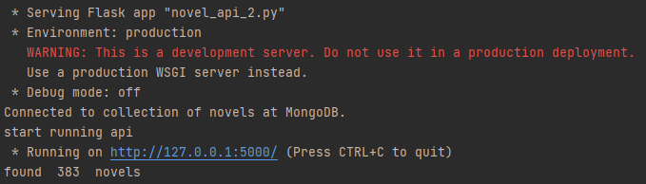

Then, go to the folder of the React app, use ‘npm install’ to install packages and ‘npm start’ to run.

If the program runs successfully, a web page will automatically open at url: localhost:3000, and the following screen will show up:

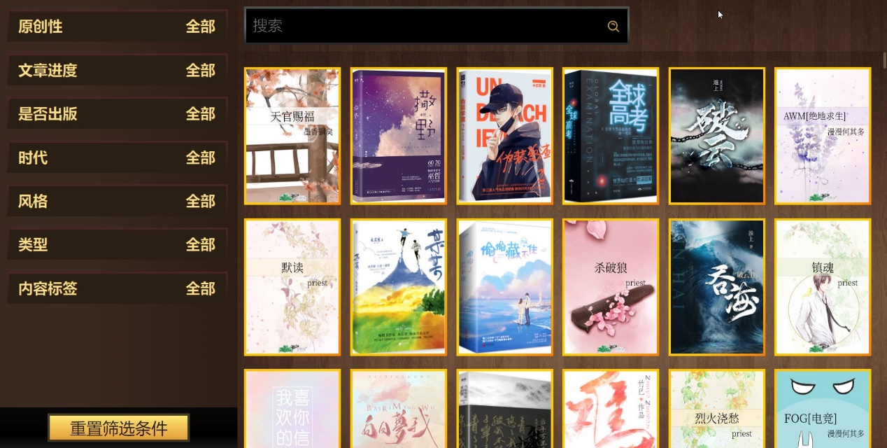

When mouse hovers over a filter bar, the font color, background, and border will change their styles as below:

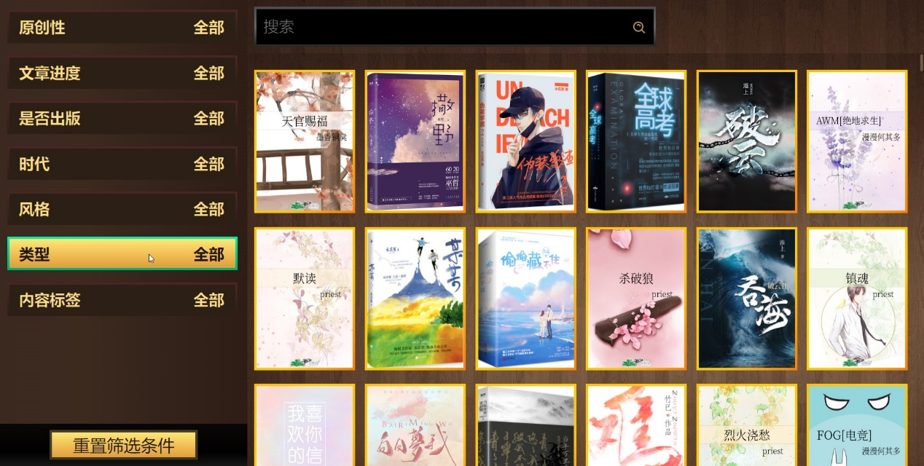

After clicking a filter bar, its filter buttons will appear below the bar, showing rows of attributes to filter with. An example is as below:

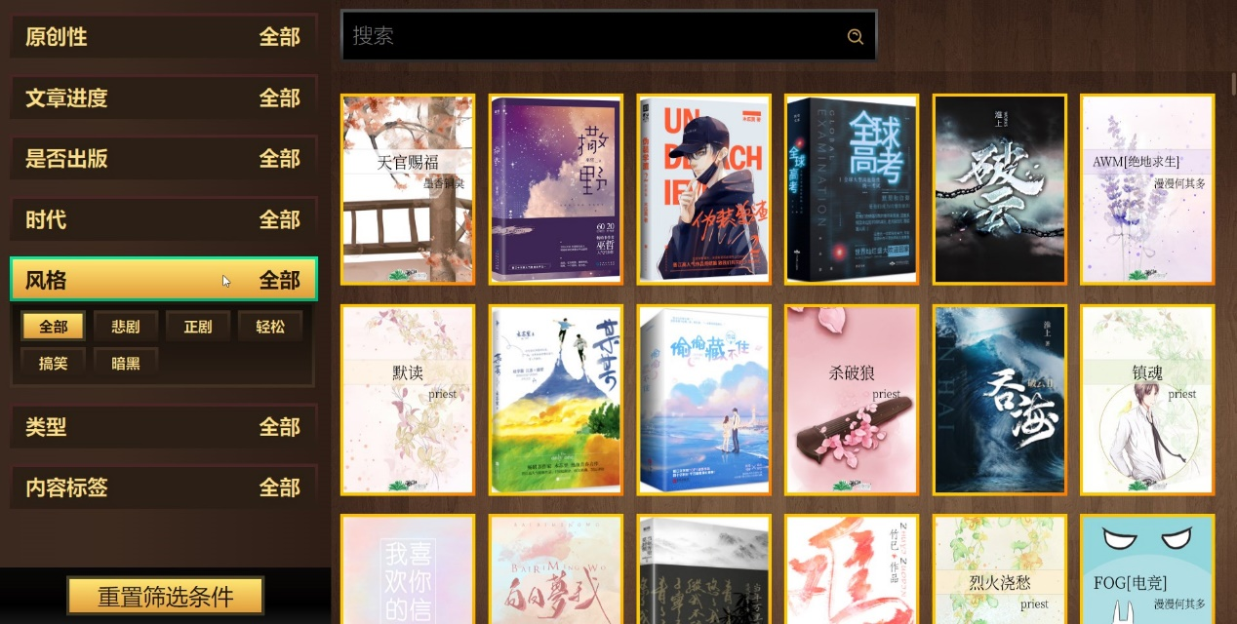

After hovering over and clicking on a filter attribute, the novel gallery will filter according to the newest filter status. In the example below, the gallery will only show novels whose风格(styles) are 暗黑:

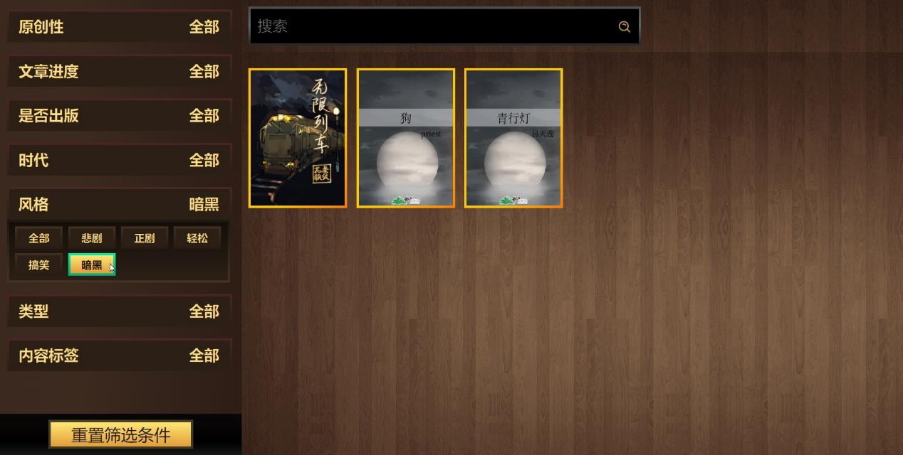

If selecting a different filter button of style, the gallery will show novels that have either the style of 悲剧 or 暗黑, because novels in our database only have one style. An example screenshot is as following:

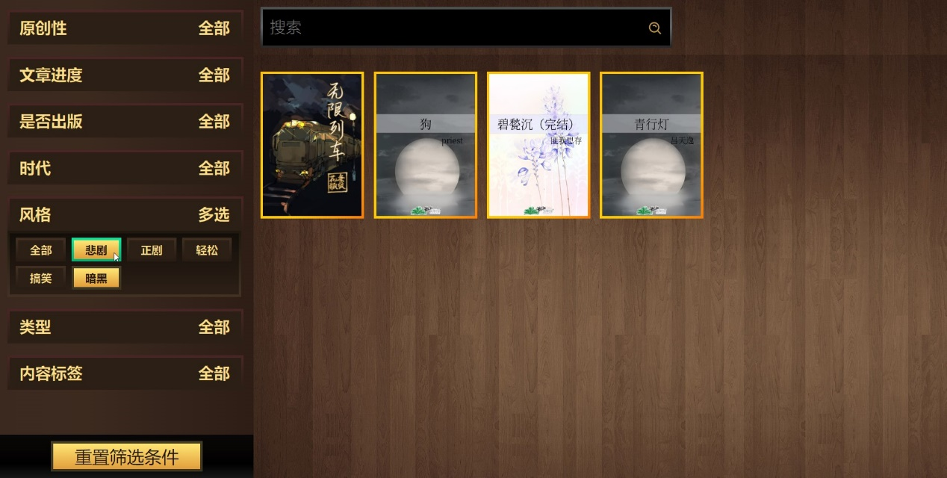

After deselecting two filter button (悲剧 and 暗黑), the button 全部 (all) will automatically be set, so that novels of all styles will show up in the gallery:

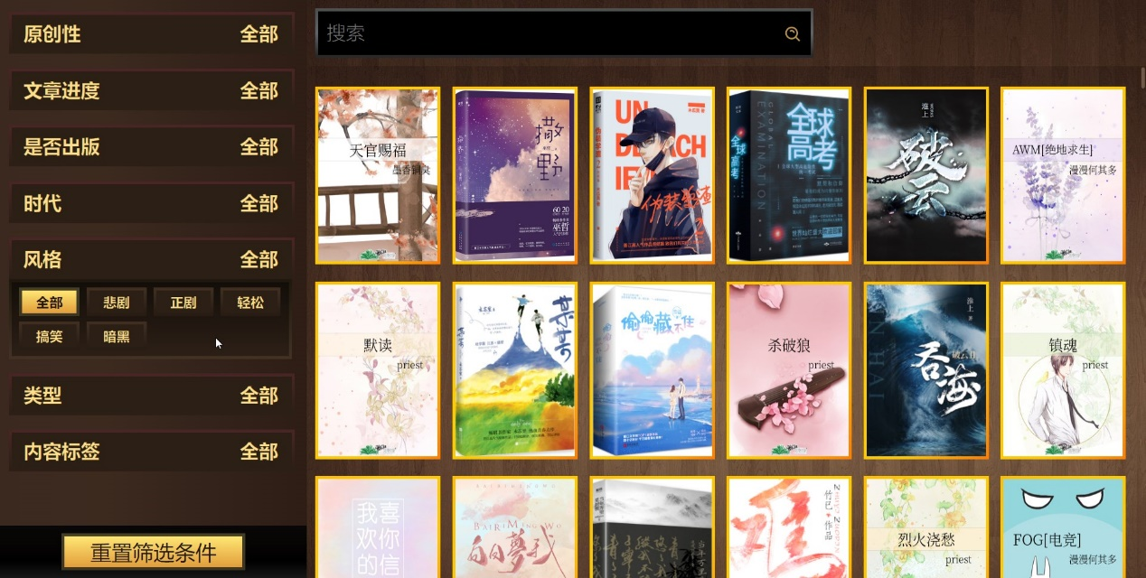

The content labels (内容标签) filter works a bit differently. Because each novel can have from zero to four content labels, selecting different content label buttons will cause the gallery to only show novels that contain all of the selected content labels.

For example, if we select ‘school’ (校园), seven novels will show up in the gallery: (note that if only one button of a filter is selected, the name of the button will show on the filter bar, otherwise ‘many’ (多选) will appear instead)

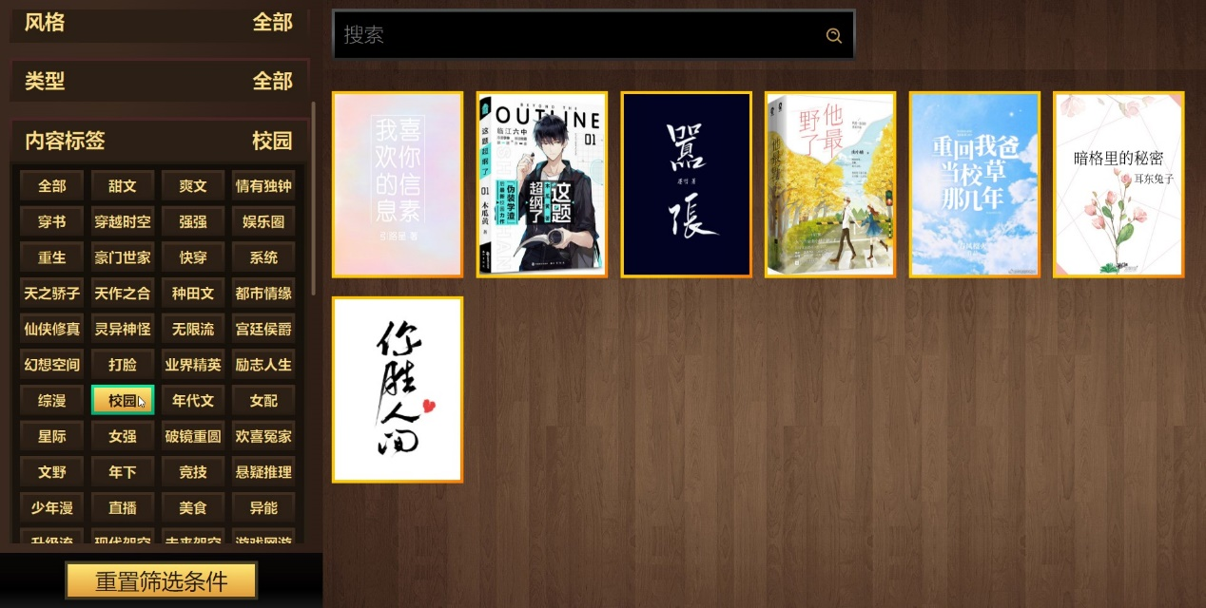

Then, select another content label button ‘sweet’ (甜文), only five of the seven novels above appear below:

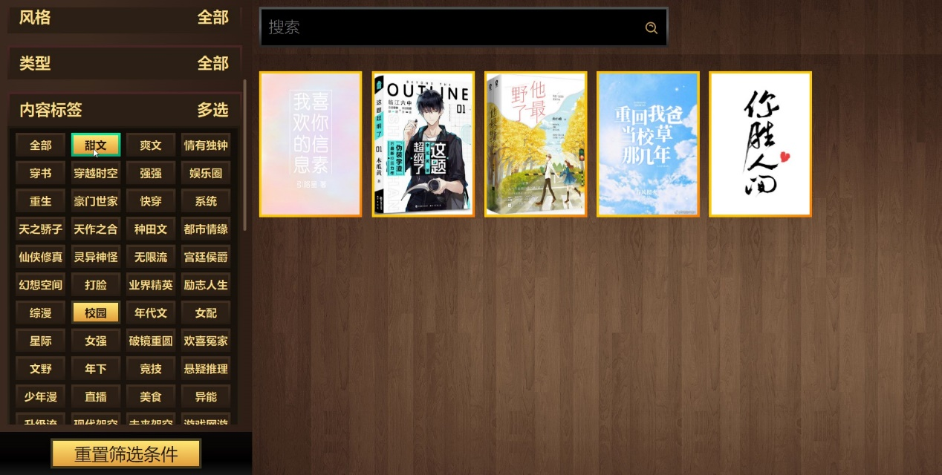

To check a detail of a novel, we can hover on the cover image of a book. The cover on hover will become a bit larger, have a border of different color, and show a detail box near itself.

The detail box contains title, author, one-sentence-description, overlord-ticket ranking, and content labels.

For example, we can hover on a novel and see that there are content labels 校园(school) and甜文(sweet) in the detail box.

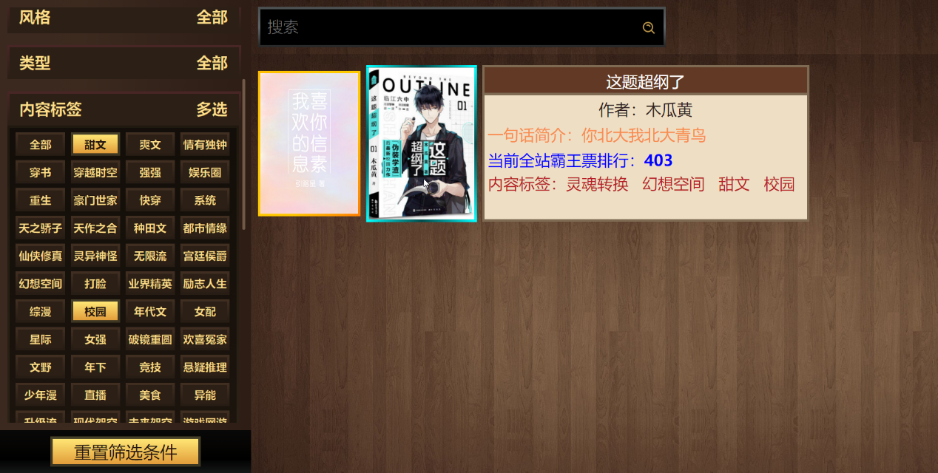

We can reset all filters by clicking ‘重置筛选条件’ at the left lower corner.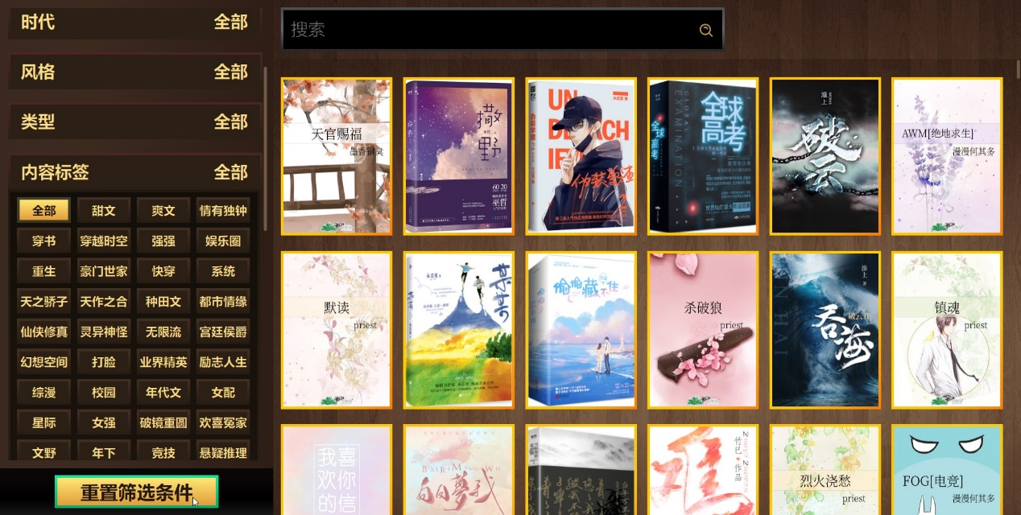

The search bar above the gallery will split input text by whitespace and search for novels whose titles or authors contain the split input texts.

For example, if we input ‘est pri’, the filter will show all novels by author ‘priest’.

